Inside Observations and Data Sheet
Name ____________________________ Date ________
Wild Animals I Observed  Write the name and draw a picture of the WILD animals you observe in movies, TV, etc. | Counting my Observations  Mark in the box below every time you observe this WILD animal. | Total times I observed this WILD animal
Example:  Spider 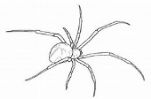 |  | 8
Add on if you see more WILD living things!

